**Assignment 10**

1. Write a program to read a text file and print the number of rows of data in the document

**Ans:**

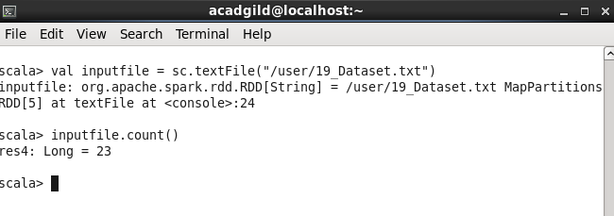

1. Write a program to read a text file and print the number of words in the document.

**Ans:**

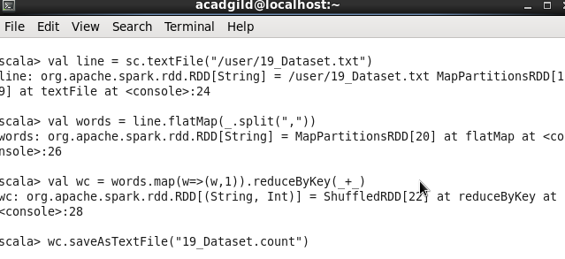

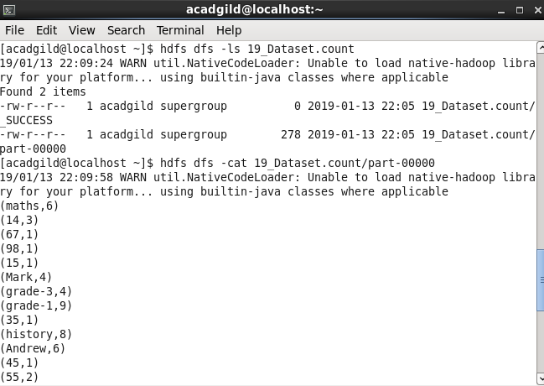

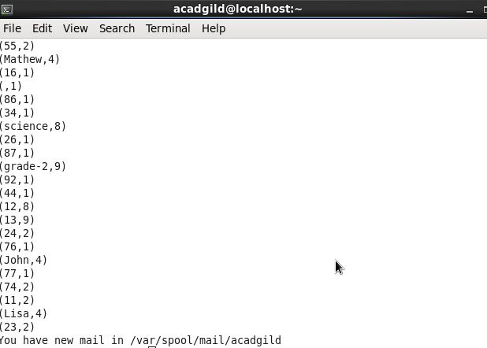

1. We have a document where the word separator is -, instead of space. Write a spark code, to obtain the count of the total number of words present in the document.

**Ans:**

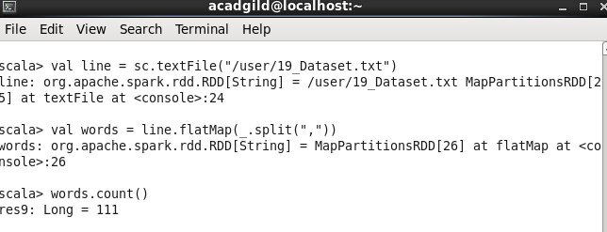

**Task 2**

**Problem Statement 1:**

1. Read the text file, and create a tuple rdd.

**Ans:**

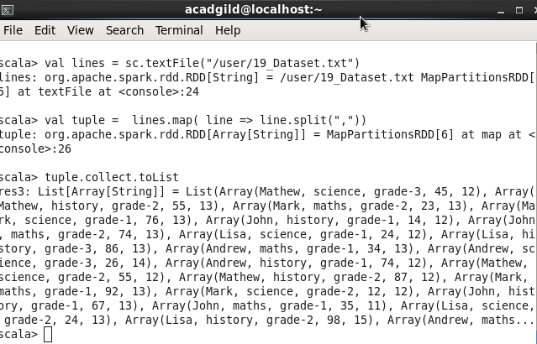

1. Find the count of total number of rows present.

Ans:

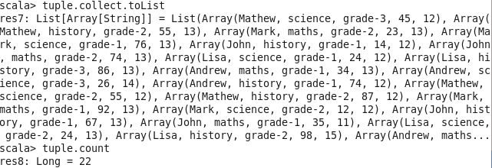

1. What is the distinct number of subjects present in the entire school?

**Ans:**

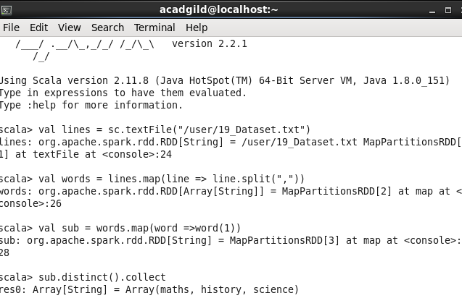

1. What is the count of the number of students in the school, whose name is Mathew and marks, are 55.

Ans:

